

SOFTWARE DESIGN SPECIFICATION
Movies Theater Online Booking System (MoviesTheater)

– Hanoi, July 2026 –

Table of Contents
I. Record of Changes 3
II. Software Design Document 4
1. High Level Design 4
1.1 Software Architecture 4
1.2 Package Diagram 4
1.3 Database Design 5
2. State Transition Diagrams 7
2.1 PIN Validation 7
2.2 … 7
3. Detailed Design 8
3.1 <Feature/Function Name1> 8
3.2 <Feature/Function Name2> 9

I. Record of Changes
Date | A*  M, D | In charge | Change Description
13/07/2026 | A | AI Assistant | Initialized the SDS document based on the SRS and the current source code.
13/07/2026 | M | AI Assistant | Expanded the Database Design section to cover the full CinemaBookingDB schema (21 tables).
15/07/2026 | M | AI Assistant | Rewrote High Level Design, State Transition Diagrams and Detailed Design to match the actual com.cinema.* packages, classes and DB constraints.
*A - Added M - Modified D - Deleted

II. Software Design Document

1. High Level Design

1.1 Software Architecture
The system follows a layered MVC architecture on top of the Jakarta Servlet API (Java 21, deployed on Apache Tomcat). The browser talks to Controller servlets under com.cinema.controller (e.g. LoginController, BookingController, MovieController, PromotionServlet); AuthFilter and EncodingFilter (com.cinema.filter) intercept every request first to enforce session authentication/authorization and UTF-8 encoding. Controllers call the Service/DAO layer (com.cinema.dao) for business logic and JDBC data access, which in turn populates Model beans (com.cinema.model) and reads/writes the CinemaBookingDB SQL Server database through DBContext/DBUtils (com.cinema.util). Controllers forward request-scoped data to JSP views under /view for rendering. A background ServletContextListener, PromotionStatusScheduler (com.cinema.listener), periodically recomputes Promotion.Status (upcoming / active / expired) independently of any user request.
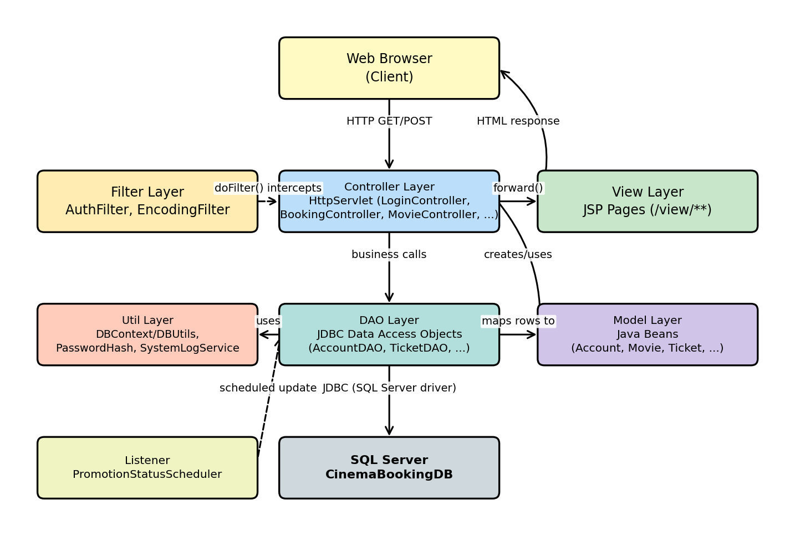
Figure 1.1 — System Architecture

1.2 Package Diagram
Source code is organized under the com.cinema root package. Controllers depend on DAOs and Models; DAOs depend on the util package for the JDBC connection and password hashing helpers; the filter package intercepts controller calls; the listener package triggers scheduled DAO calls outside the request/response cycle; and the exception package holds the custom exceptions (ValidationException, NotFoundException, ConflictException) that controllers throw and catch to return proper HTTP/JSP error responses.
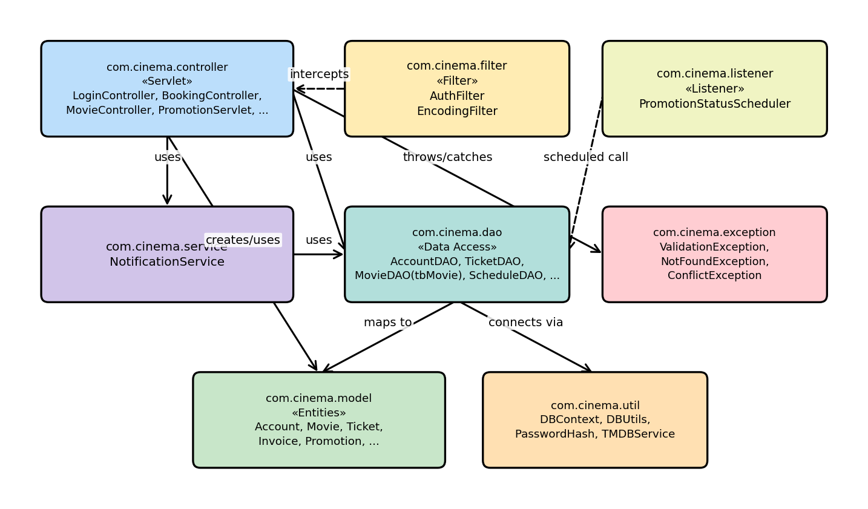
Figure 1.2 — Package Diagram
Package descriptions
No | Package | Description
01 | com.cinema.controller | HttpServlet controllers (Presentation Logic Layer): routes HTTP requests, validates input, calls DAOs/services, and forwards to JSP views. E.g. LoginController, BookingController, MovieController, PromotionServlet, AdminServlet.
02 | com.cinema.dao | Data Access Objects: raw JDBC (PreparedStatement) access to SQL Server. E.g. AccountDAO, TicketDAO, tbMovie, ScheduleDAO, PromotionDAO.
03 | com.cinema.model | Plain Java beans mirroring the database entities (Account, Movie, Ticket, Invoice, Promotion, Seat, Schedule, ...) plus view/DTO-style helper beans (SeatView, BookingScheduleView, BookingCart).
04 | com.cinema.service | Cross-cutting business services used by multiple controllers, e.g. NotificationService.
05 | com.cinema.util | Shared utilities: DBContext/DBUtils (JDBC connection pooling), PasswordHash, SystemLogService (audit log), GoogleOAuthConfig, TMDBService.
06 | com.cinema.filter | Servlet filters applied to every request: AuthFilter (session/role check) and EncodingFilter (UTF-8).
07 | com.cinema.listener | ServletContextListener implementations that run background/scheduled logic, e.g. PromotionStatusScheduler.
08 | com.cinema.exception | Custom checked/unchecked exceptions used across the DAO/controller layers: ValidationException, NotFoundException, ConflictException.

1.3 Database Design
The system uses a single SQL Server database, CinemaBookingDB, made up of 21 tables grouped into five functional areas: Role & Account Management, Movie Information, Cinema Layout & Scheduling, Booking & Transactions, and Employee Management & Logging. The grouping and the main foreign-key relationships between tables are shown below; the full column-level definition of every table follows in sections 1.3.1–1.3.21.
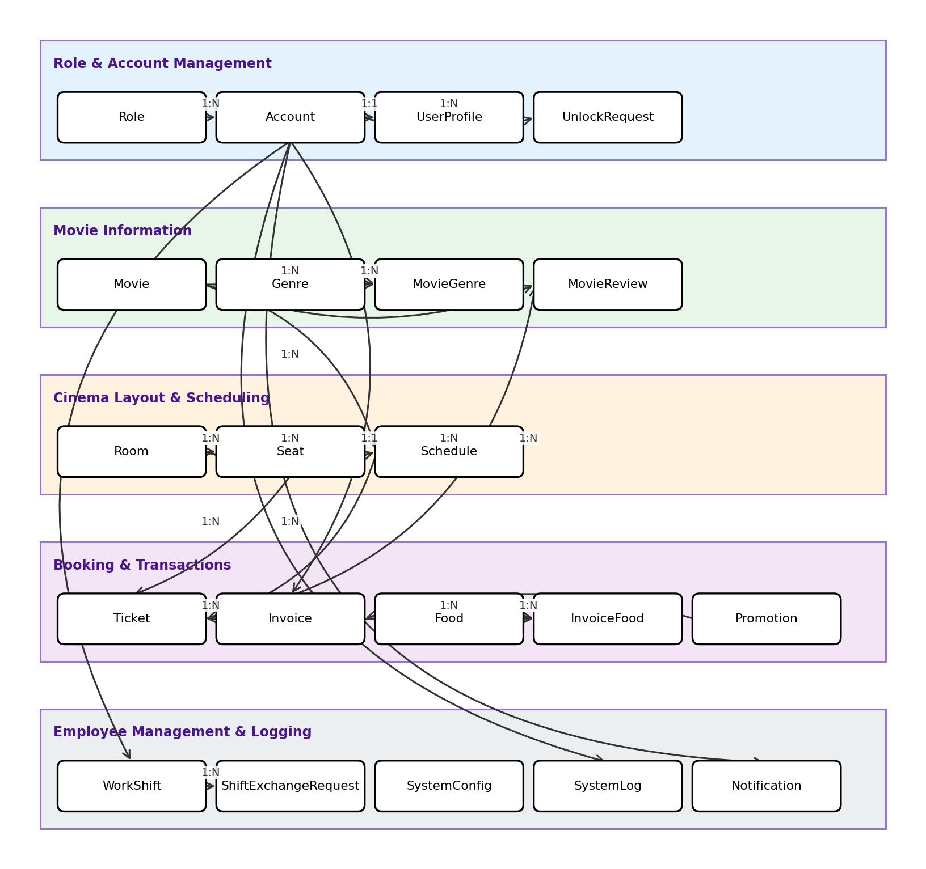
Figure 1.3 — Database table grouping and relationships
* PK = Primary Key; FK = Foreign Key; UN = Unique; NN = Not Null.

1.3.1 Role
Lookup table defining the account roles used for access control (Guest, Customer, Employee, Manager, SystemAdmin).
No | Field | PK | FK | UN | NN | Description
01 | RoleID | x |  |  | x | Primary key, auto-increment.
02 | RoleName |  |  | x | x | Unique role name (e.g. 'Customer', 'Employee').

1.3.2 Account
Core login credentials and account state for every user of the system (customer, employee, manager, admin).
No | Field | PK | FK | UN | NN | Description
01 | AccountID | x |  |  | x | Primary key, auto-increment.
02 | Email |  |  | x | x | Unique login email.
03 | Password |  |  |  | x | Hashed password (see PasswordHash util).
04 | RoleID |  | x |  | x | FK -> Role.RoleID.
05 | IsBlocked |  |  |  | x | 1 if the account has been locked by an admin. Default 0.
06 | AccountStatus |  |  |  | x | Employee onboarding status (e.g. 'noneed', 'pending_setup'). Default 'noneed'.
07 | CreatedAt |  |  |  | x | Row creation timestamp. Default GETDATE().
08 | ResetToken |  |  |  |  | One-time token issued for a password-reset request.
09 | ResetTokenExpiry |  |  |  |  | Expiry timestamp for ResetToken.

1.3.3 UserProfile
Extended personal profile information for an Account (1:1).
No | Field | PK | FK | UN | NN | Description
01 | AccountID | x | x |  | x | Primary key and FK -> Account.AccountID.
02 | FullName |  |  |  |  | Display name.
03 | PhoneNumber |  |  |  |  | Contact phone number.
04 | DoB |  |  |  |  | Date of birth.
05 | Address |  |  |  |  | Mailing address.
06 | AvatarURL |  |  |  |  | URL of the profile picture.

1.3.4 UnlockRequest
Request submitted by a blocked user asking an admin/manager to unblock their Account.
No | Field | PK | FK | UN | NN | Description
01 | RequestID | x |  |  | x | Primary key, auto-increment.
02 | AccountID |  | x |  | x | FK -> Account.AccountID (the blocked account).
03 | Reason |  |  |  |  | Reason text supplied by the user.
04 | Status |  |  |  | x | 'Pending' / 'Approved' / 'Rejected'. Default 'Pending'.
05 | ReviewedBy |  | x |  |  | FK -> Account.AccountID (the reviewing admin).
06 | CreatedAt |  |  |  | x | Request creation timestamp.
07 | ReviewedAt |  |  |  |  | Timestamp the request was reviewed.

1.3.5 Movie
Metadata for a movie title available at the cinema.
No | Field | PK | FK | UN | NN | Description
01 | MovieID | x |  |  | x | Primary key, auto-increment.
02 | MovieName |  |  |  | x | Title of the movie.
03 | Description |  |  |  |  | Synopsis.
04 | Duration |  |  |  | x | Runtime in minutes.
05 | ReleaseDate |  |  |  |  | Release date.
06 | Poster |  |  |  |  | Poster image URL.
07 | Trailer |  |  |  |  | Trailer video URL.
08 | Language |  |  |  |  | Audio language.
09 | Subtitle |  |  |  |  | Subtitle language.
10 | Director |  |  |  |  | Director name.
11 | Cast |  |  |  |  | Leading cast.
12 | Country |  |  |  |  | Country of origin.
13 | AgeRestriction |  |  |  | x | Minimum viewer age. Default 0.
14 | IsActive |  |  |  | x | Whether the movie is currently listed. Default 1.
15 | DateAdded |  |  |  |  | Timestamp the movie was added to the catalog.
16 | Budget |  |  |  |  | Production budget (display text, TMDB import).
17 | GlobalBoxOffice |  |  |  |  | Worldwide box-office figure (display text, TMDB import).
18 | WeeklyRevenueRank |  |  |  |  | Cached ranking used on the homepage. Default 0.
19 | TicketsSoldMilestone |  |  |  |  | Cached milestone counter for marketing badges. Default 0.

1.3.6 Genre
Lookup table of movie genres.
No | Field | PK | FK | UN | NN | Description
01 | GenreID | x |  |  | x | Primary key, auto-increment.
02 | GenreName |  |  | x | x | Unique genre name.

1.3.7 MovieGenre
Junction table implementing the Movie <-> Genre many-to-many relationship.
No | Field | PK | FK | UN | NN | Description
01 | MovieID | x | x |  | x | FK -> Movie.MovieID (composite PK).
02 | GenreID | x | x |  | x | FK -> Genre.GenreID (composite PK).

1.3.8 MovieReview
Customer rating/comment for a movie, tied to a specific paid Ticket (one review per ticket).
No | Field | PK | FK | UN | NN | Description
01 | ReviewID | x |  |  | x | Primary key, auto-increment.
02 | MovieID |  | x |  | x | FK -> Movie.MovieID.
03 | AccountID |  | x |  | x | FK -> Account.AccountID (reviewer).
04 | TicketID |  | x | x | x | FK -> Ticket.TicketID; unique, so each ticket yields at most one review.
05 | RatingValue |  |  |  | x | Star rating, 1-5 (CHECK constraint).
06 | Comment |  |  |  |  | Free-text review comment.
07 | CreatedAt |  |  |  | x | Timestamp the review was submitted.

1.3.9 Room
A physical screening room (auditorium) in the cinema.
No | Field | PK | FK | UN | NN | Description
01 | RoomID | x |  |  | x | Primary key, auto-increment.
02 | RoomNumber |  |  | x | x | Unique room code (e.g. 'P01').
03 | RoomType |  |  |  | x | '2D' / '3D' / 'IMAX' / '4DX' (CHECK constraint). Default '2D'.
04 | Capacity |  |  |  | x | Total seat count.
05 | NumberOfRows |  |  |  | x | Number of seat rows. Default 5.
06 | SeatsPerRow |  |  |  | x | Seats per row. Default 10.
07 | IsActive |  |  |  | x | Whether the room is in service. Default 1.

1.3.10 Seat
A single physical seat inside a Room.
No | Field | PK | FK | UN | NN | Description
01 | SeatID | x |  |  | x | Primary key, auto-increment.
02 | RoomID |  | x |  | x | FK -> Room.RoomID.
03 | RowChar |  |  |  | x | Row letter (e.g. 'A'). Combined with ColNumber, unique per room.
04 | ColNumber |  |  |  | x | Column number within the row.
05 | SeatType |  |  |  | x | 'Normal' / 'VIP' / 'Couple' (CHECK constraint). Default 'Normal'.
06 | IsActive |  |  |  | x | Whether the seat is bookable. Default 1.

1.3.11 Schedule
A single showtime: a Movie screened in a Room at a given time.
No | Field | PK | FK | UN | NN | Description
01 | ScheduleID | x |  |  | x | Primary key, auto-increment.
02 | RoomID |  | x |  | x | FK -> Room.RoomID.
03 | MovieID |  | x |  | x | FK -> Movie.MovieID.
04 | StartTime |  |  |  | x | Showtime start.
05 | EndTime |  |  |  | x | Showtime end (denormalized for query performance; CHECK EndTime > StartTime).
06 | BaseTicketPrice |  |  |  | x | Base price for a Normal seat; VIP/Couple seats apply a multiplier.
07 | Status |  |  |  | x | 'Scheduled' / 'Ongoing' / 'Finished' / 'Cancelled' (CHECK constraint). Default 'Scheduled'.

1.3.12 Food
A concession item (popcorn, drink, combo, ...) that can be added to a booking.
No | Field | PK | FK | UN | NN | Description
01 | FoodID | x |  |  | x | Primary key, auto-increment.
02 | FoodName |  |  |  | x | Item name.
03 | Price |  |  |  | x | Unit price.
04 | Image |  |  |  |  | Item image URL.
05 | IsActive |  |  |  | x | Whether the item is currently sellable. Default 1.

1.3.13 Promotion
A discount code with usage limits and a validity window.
No | Field | PK | FK | UN | NN | Description
01 | PromotionID | x |  |  | x | Primary key, auto-increment.
02 | PromotionCode |  |  | x | x | Unique code entered by the customer.
03 | Description |  |  |  |  | Human-readable description.
04 | DiscountType |  |  |  | x | 'Percentage' / 'FlatAmount' (CHECK constraint).
05 | DiscountValue |  |  |  | x | Discount magnitude (percent or flat VND amount; CHECK > 0).
06 | MinOrderAmount |  |  |  | x | Minimum subtotal required to apply the code. Default 0.
07 | MaxDiscountAmount |  |  |  |  | Cap on the discount amount for percentage-type codes.
08 | StartDate |  |  |  | x | Validity start (CHECK EndDate > StartDate).
09 | EndDate |  |  |  | x | Validity end.
10 | UsageLimit |  |  |  |  | Maximum number of times the code can be used, if capped.
11 | UsedCount |  |  |  | x | Running count of successful uses. Default 0.
12 | IsActive |  |  |  | x | Manually toggled on/off by staff. Default 1.
13 | Status |  |  |  | x | Derived lifecycle state: 'upcoming' / 'active' / 'expired' / 'inactive' (CHECK constraint), kept in sync by PromotionStatusScheduler.

1.3.14 Invoice
A payable order: one or more Tickets (and optional Food) purchased together.
No | Field | PK | FK | UN | NN | Description
01 | InvoiceID | x |  |  | x | Primary key, auto-increment.
02 | AccountID |  | x |  | x | FK -> Account.AccountID (the buyer).
03 | PromotionID |  | x |  |  | FK -> Promotion.PromotionID, if a code was applied.
04 | SubTotal |  |  |  | x | Sum of ticket + food prices before discount.
05 | DiscountAmount |  |  |  | x | Amount deducted by the applied promotion. Default 0.
06 | TotalAmount |  |  |  | x | SubTotal minus DiscountAmount.
07 | PaymentMethod |  |  |  | x | 'Cash' / 'VNPay' / 'MoMo' / 'ZaloPay'.
08 | PaymentStatus |  |  |  | x | 'Pending' / 'Paid' / 'Failed' / 'Refunded' (CHECK constraint). Default 'Pending'.
09 | CreatedAt |  |  |  | x | Order timestamp. Default GETDATE().

1.3.15 Ticket
A single booked seat for a Schedule, linked to the Invoice that paid for it.
No | Field | PK | FK | UN | NN | Description
01 | TicketID | x |  |  | x | Primary key, auto-increment.
02 | ScheduleID |  | x |  | x | FK -> Schedule.ScheduleID.
03 | SeatID |  | x |  | x | FK -> Seat.SeatID.
04 | InvoiceID |  | x |  | x | FK -> Invoice.InvoiceID.
05 | PriceAtBooking |  |  |  | x | Seat price captured at booking time (survives later price changes).
06 | Code |  |  | x | x | Unique QR/ticket code shown at check-in.
07 | IsCheckedIn |  |  |  | x | 1 once the ticket has been scanned at the door. Default 0.
08 | CheckedInAt |  |  |  |  | Check-in timestamp.

1.3.16 InvoiceFood
Junction table implementing the Invoice <-> Food many-to-many relationship (food items purchased per invoice).
No | Field | PK | FK | UN | NN | Description
01 | InvoiceID | x | x |  | x | FK -> Invoice.InvoiceID (composite PK).
02 | FoodID | x | x |  | x | FK -> Food.FoodID (composite PK).
03 | Quantity |  |  |  | x | Quantity purchased (CHECK > 0). Default 1.
04 | PriceAtBooking |  |  |  | x | Unit price captured at purchase time.

1.3.17 WorkShift
A scheduled work shift assigned to an employee Account.
No | Field | PK | FK | UN | NN | Description
01 | ShiftID | x |  |  | x | Primary key, auto-increment.
02 | EmployeeID |  | x |  | x | FK -> Account.AccountID.
03 | ShiftDate |  |  |  | x | Calendar date of the shift.
04 | StartTime |  |  |  | x | Shift start time.
05 | EndTime |  |  |  | x | Shift end time.
06 | Status |  |  |  | x | 'Scheduled' / 'Completed' / 'Absent' (CHECK constraint). Default 'Scheduled'.
07 | Notes |  |  |  |  | Free-text notes.
08 | CreatedAt |  |  |  | x | Row creation timestamp.

1.3.18 ShiftExchangeRequest
A request from one employee to swap a WorkShift with another employee.
No | Field | PK | FK | UN | NN | Description
01 | RequestID | x |  |  | x | Primary key, auto-increment.
02 | ShiftID |  | x |  | x | FK -> WorkShift.ShiftID (ON DELETE CASCADE).
03 | RequesterID |  | x |  | x | FK -> Account.AccountID (employee requesting the swap).
04 | TargetEmpID |  | x |  | x | FK -> Account.AccountID (employee asked to take the shift).
05 | Message |  |  |  |  | Optional message from the requester.
06 | Status |  |  |  | x | 'Pending' / 'Accepted' / 'Rejected' / 'Cancelled' (CHECK constraint). Default 'Pending'.
07 | CreatedAt |  |  |  | x | Request creation timestamp.
08 | RespondedAt |  |  |  |  | Timestamp the target employee responded.

1.3.19 SystemLog
Audit log entry for security- and account-relevant actions (login success/failure, blocking, etc.).
No | Field | PK | FK | UN | NN | Description
01 | LogID | x |  |  | x | Primary key, auto-increment.
02 | AccountID |  | x |  |  | FK -> Account.AccountID; nullable for anonymous events.
03 | ActionType |  |  |  | x | Short action code, e.g. 'LOGIN_SUCCESS', 'LOGIN_BLOCKED'.
04 | Description |  |  |  |  | Human-readable detail.
05 | IPAddress |  |  |  |  | Client IP address.
06 | CreatedAt |  |  |  | x | Event timestamp.

1.3.20 Notification
An in-app notification delivered to an Account (e.g. shift-exchange response, promotion alert).
No | Field | PK | FK | UN | NN | Description
01 | NotificationID | x |  |  | x | Primary key, auto-increment.
02 | AccountID |  | x |  | x | FK -> Account.AccountID (recipient).
03 | Type |  |  |  | x | Notification category code.
04 | Title |  |  |  | x | Short title.
05 | Message |  |  |  | x | Notification body text.
06 | ReferenceID |  |  |  |  | Optional ID of the related entity (e.g. ShiftExchangeRequest).
07 | IsRead |  |  |  | x | 1 once the user has read it. Default 0.
08 | CreatedAt |  |  |  | x | Creation timestamp.

1.3.21 SystemConfig
Key/value store for cinema-wide configuration (name, contact info, booking limits, ...).
No | Field | PK | FK | UN | NN | Description
01 | ConfigKey | x |  |  | x | Primary key: configuration key, e.g. 'max_seats_per_booking'.
02 | ConfigValue |  |  |  |  | Configuration value, stored as text.
03 | Description |  |  |  |  | Human-readable description of the setting.
04 | UpdatedAt |  |  |  | x | Timestamp of the last update.
05 | UpdatedBy |  | x |  |  | FK -> Account.AccountID (admin who last changed it).

2. State Transition Diagrams
This section documents the lifecycle of the three entities whose state changes drive the main business rules of the system: a booked Seat/Ticket, a Promotion, and an Invoice's payment status. Each diagram lists the triggering event and, where applicable, the controller/DAO method or database CHECK constraint that enforces it.

2.1 Seat / Ticket Booking State
A seat moves from Available to Held while it sits in a customer's BookingCart, to Booked once BookingController/TicketDAO.createManualBooking() has written the Invoice and Ticket rows, and to Sold once Invoice.PaymentStatus becomes 'Paid'. CheckedIn is reached when staff scan the ticket's QR Code at the door (Ticket.IsCheckedIn = 1).
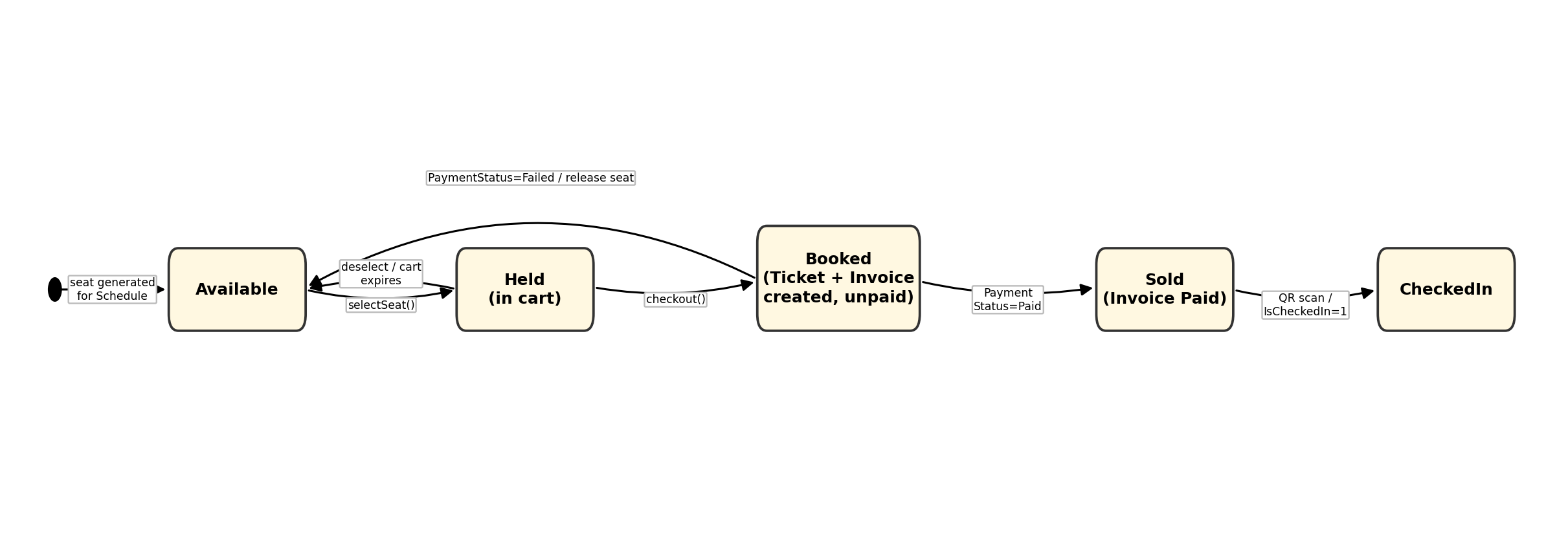
Figure 2.1 — Seat / Ticket booking state diagram

2.2 Promotion Status State
Promotion.Status is a derived field constrained to 'upcoming' / 'active' / 'expired' / 'inactive' by a database CHECK constraint. PromotionServlet updates it directly in response to admin actions (create, deactivate, reactivate, activate-early); the background PromotionStatusScheduler listener re-evaluates every promotion's dates on a timer to move upcoming -> active and active -> expired even without any admin action.
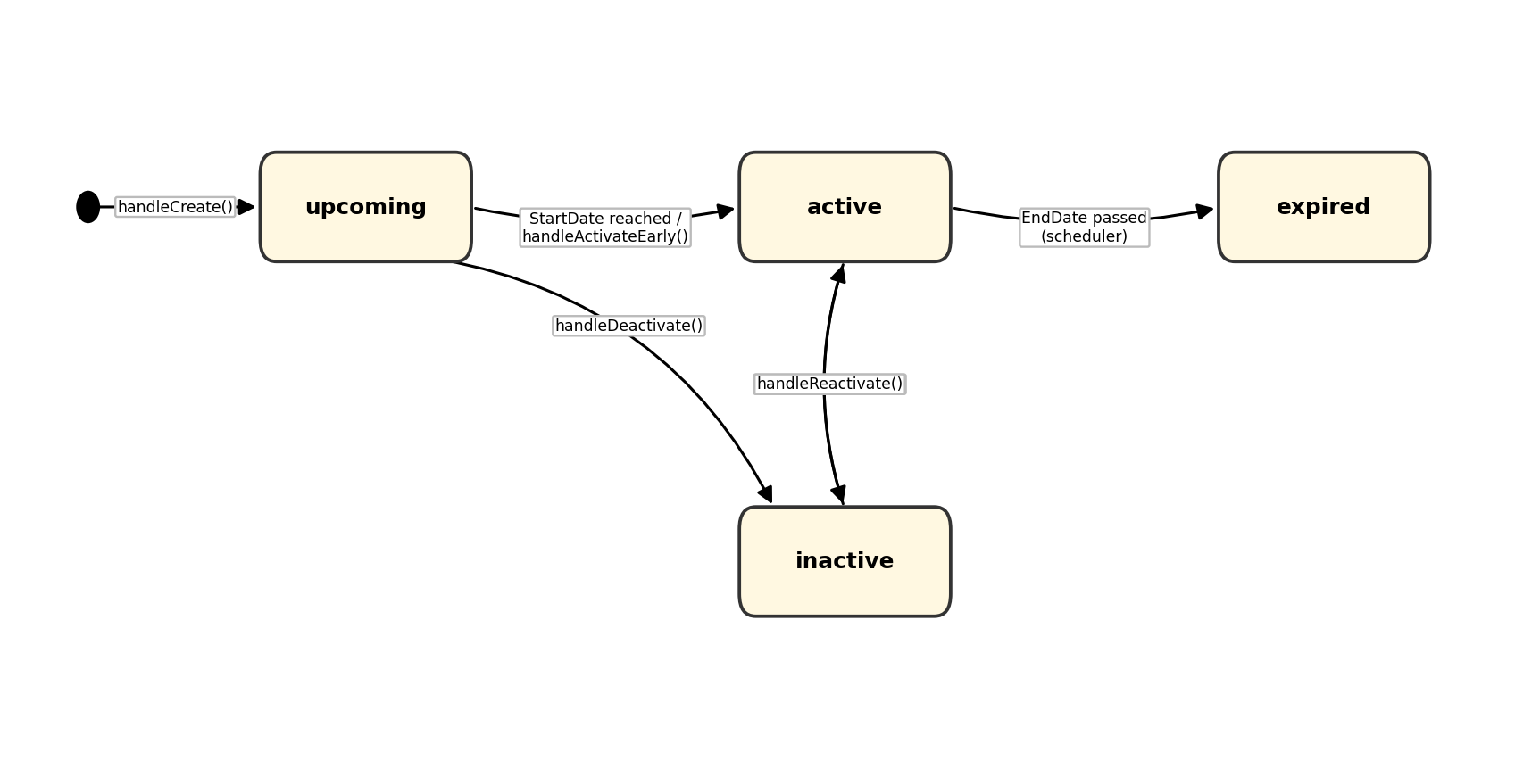
Figure 2.2 — Promotion status state diagram

2.3 Invoice Payment Status State
Invoice.PaymentStatus is constrained to 'Pending' / 'Paid' / 'Failed' / 'Refunded' by a database CHECK constraint. It starts at 'Pending' the moment TicketDAO inserts the Invoice row, and is updated once a payment result (cashier confirmation, gateway callback, or admin cancellation) is known.
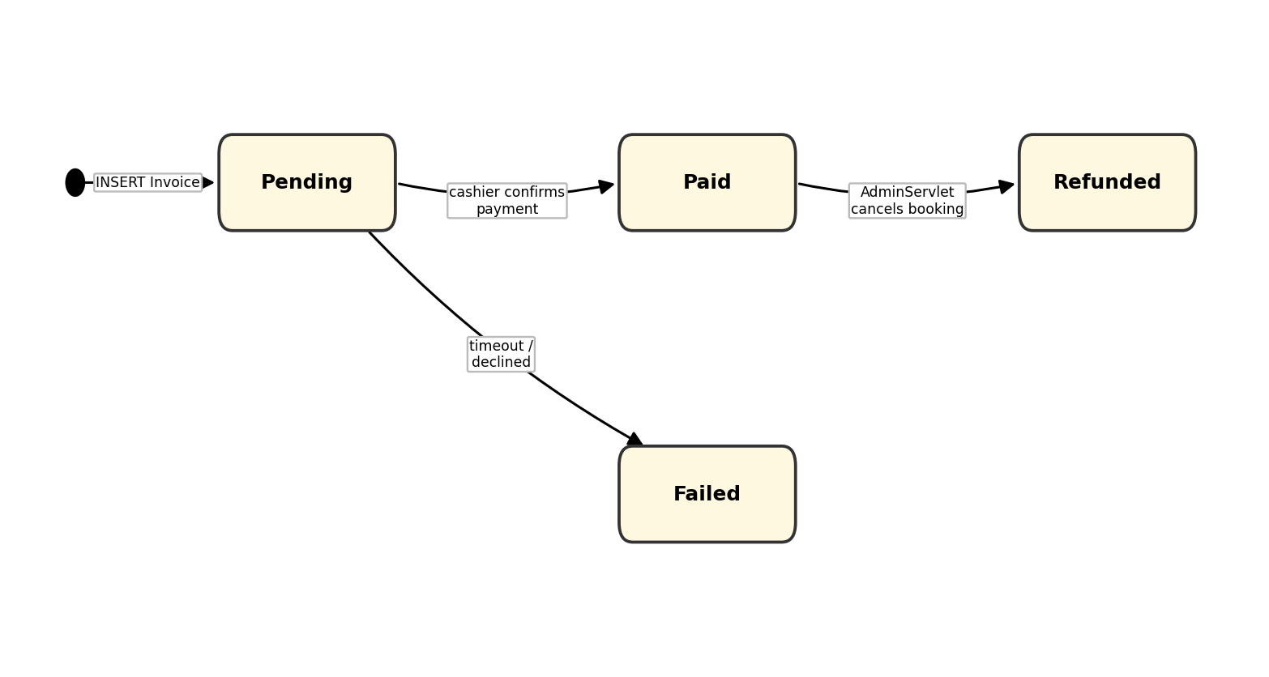
Figure 2.3 — Invoice payment status state diagram

3. Detailed Design

3.1 Authentication & Account Management
Covers login, registration and password recovery. LoginController and RegisterController (com.cinema.controller) delegate credential checks and persistence to AccountDAO, which uses PasswordHash to hash/verify passwords. AuthFilter reads the session-scoped Account on every subsequent request to enforce role-based access.

3.1.1 Class Diagram
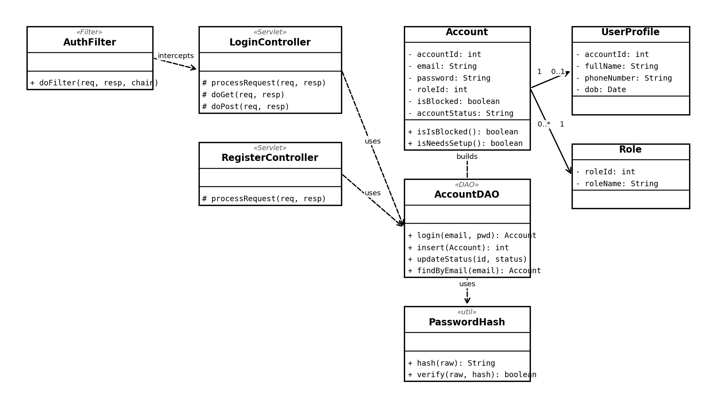
Figure 3.1.1 — Authentication & Account Management class diagram

3.1.2 Login Sequence Diagram
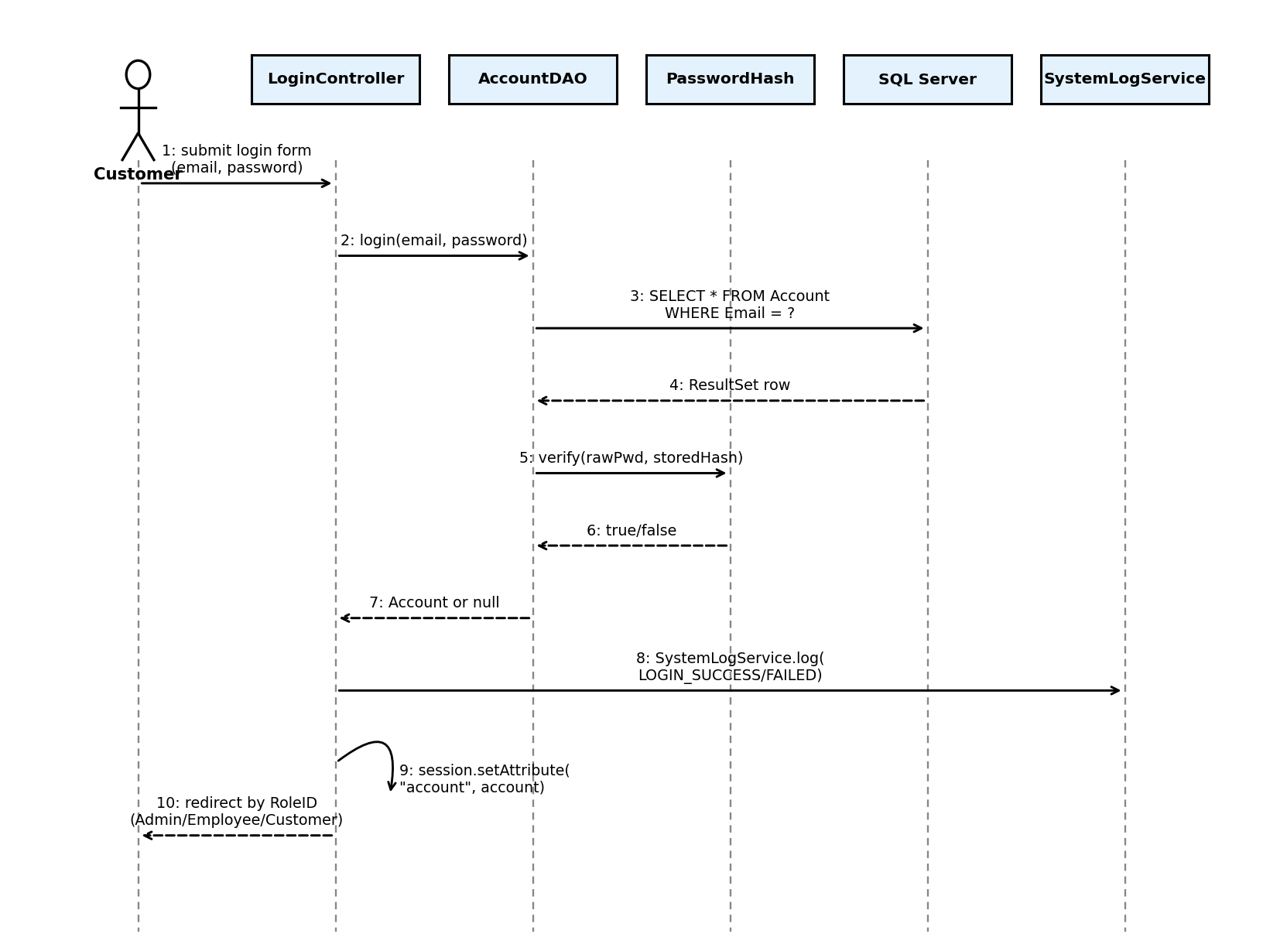
Figure 3.1.2 — Login sequence diagram

3.1.3 Register Sequence Diagram
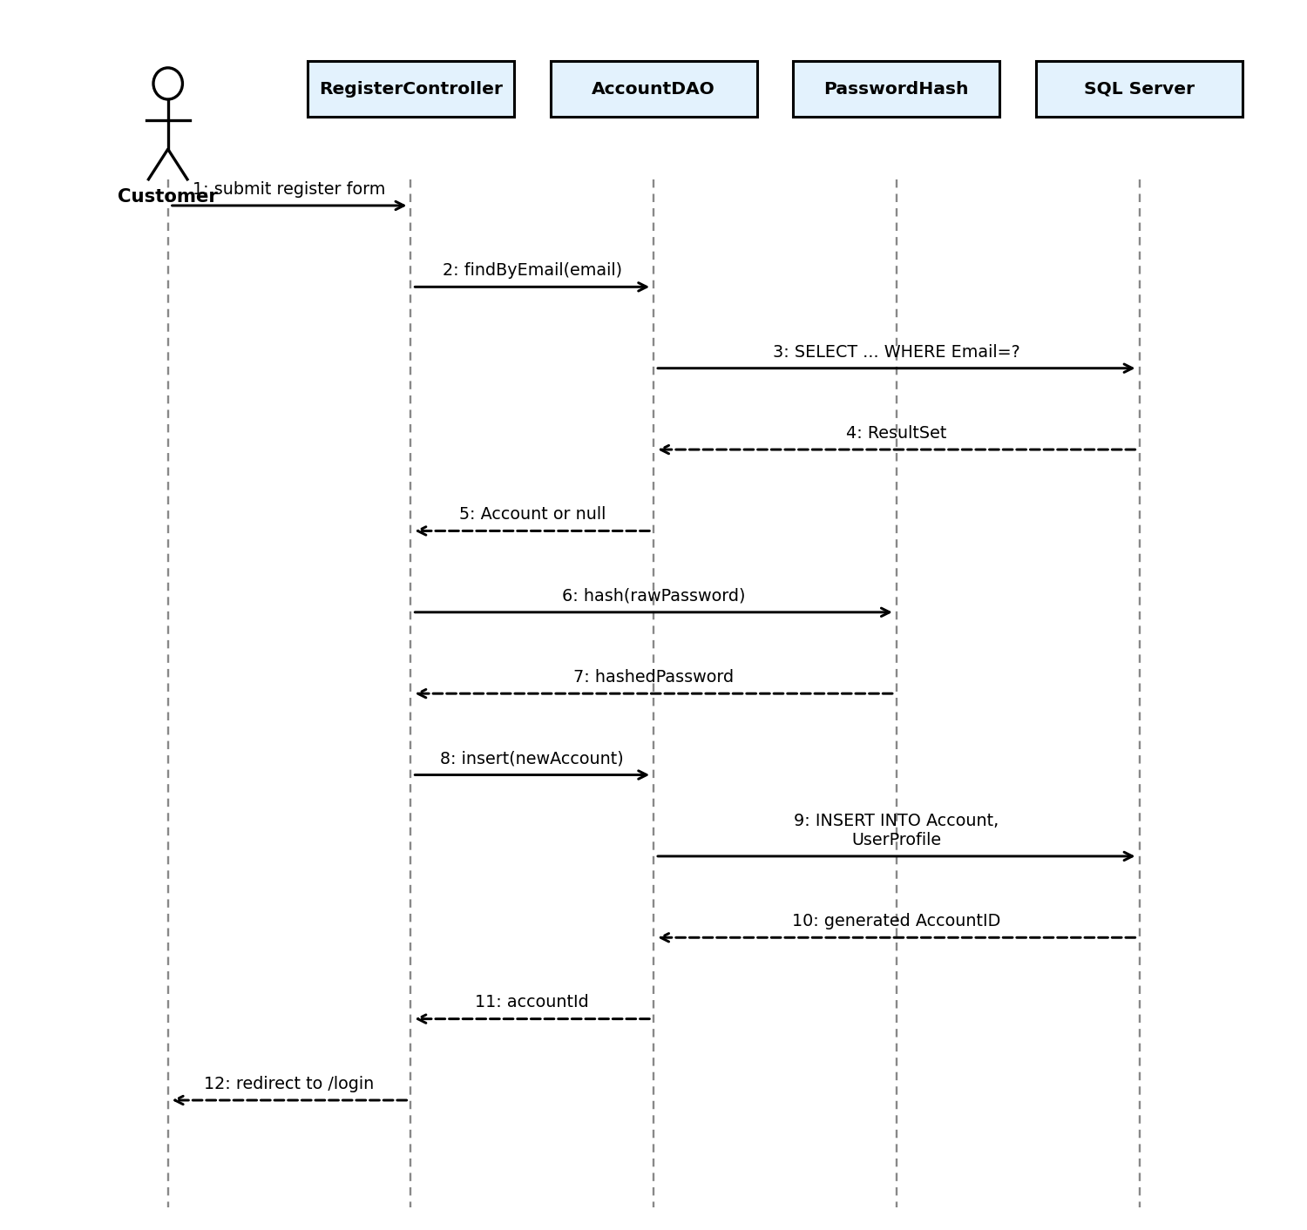
Figure 3.1.3 — Register sequence diagram

3.2 Ticket Booking & Payment
Covers seat selection, food add-ons and checkout. BookingController keeps the in-progress selection in a session-scoped BookingCart, backed by BookingScheduleDAO and BookingSeatDAO for read queries. At checkout, TicketDAO.createManualBooking() runs a single JDBC transaction that inserts the Invoice, one Ticket per selected seat, and increments Promotion.UsedCount when a discount code was applied.

3.2.1 Class Diagram
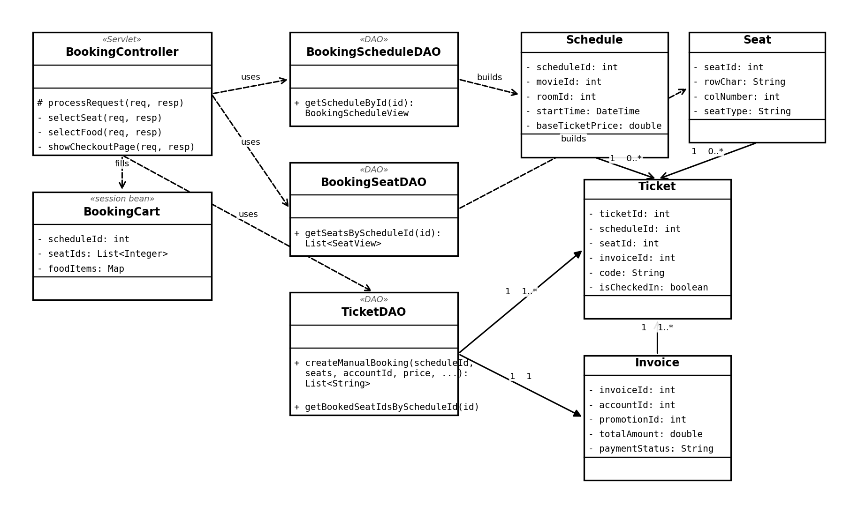
Figure 3.2.1 — Ticket Booking & Payment class diagram

3.2.2 Seat Selection Sequence Diagram
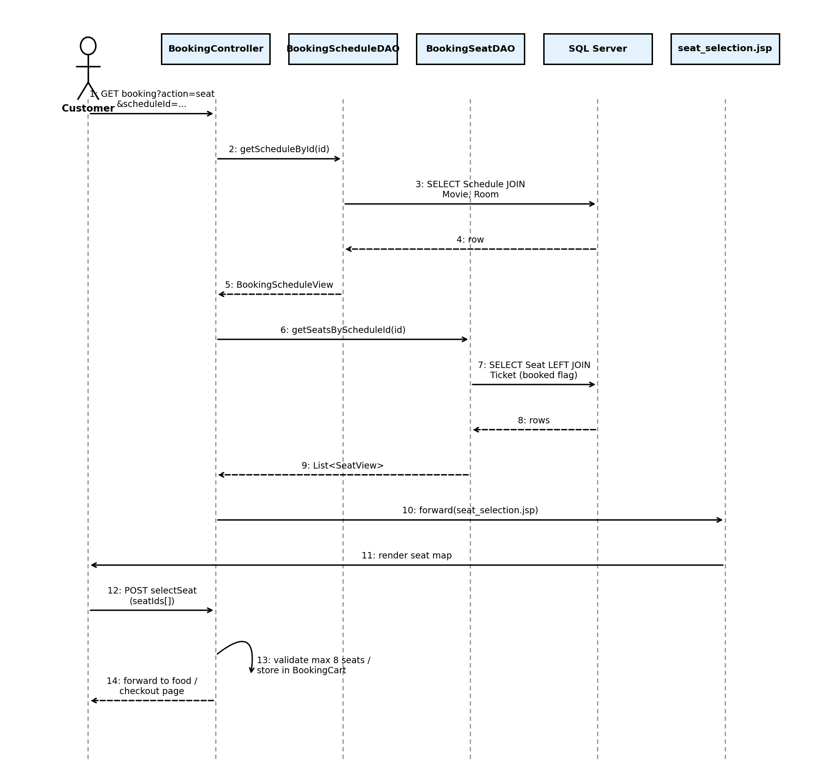
Figure 3.2.2 — Seat selection sequence diagram

3.2.3 Checkout / Payment Sequence Diagram
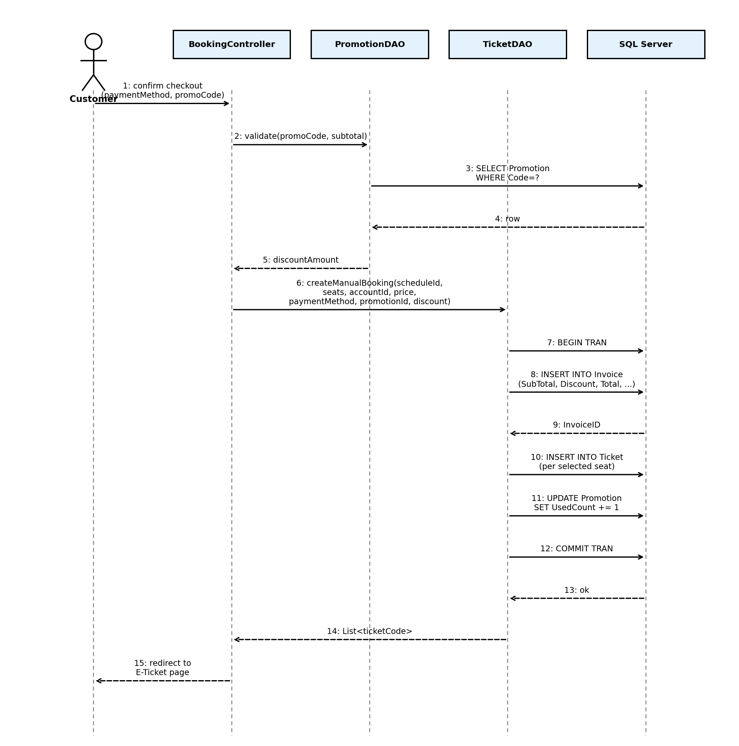
Figure 3.2.3 — Checkout / payment sequence diagram

3.3 Movie & Schedule Management (Admin)
Covers the admin-side CRUD flows for movies, genres, rooms and showtimes. MovieController persists movies via the legacy-named tbMovie DAO onto the clsMovie model; GenreController/GenreDAO, ScheduleController/ScheduleDAO and RoomServlet/RoomDAO follow the same Controller -> DAO -> Model pattern for their respective entities.

3.3.1 Class Diagram
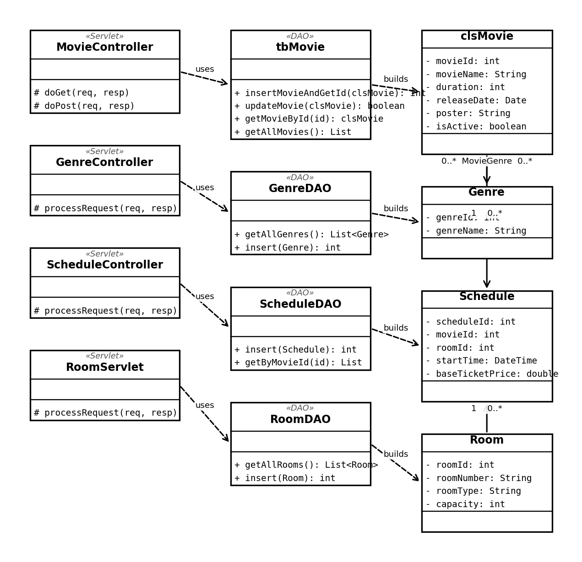
Figure 3.3.1 — Movie & Schedule Management class diagram

3.3.2 Add Movie Sequence Diagram
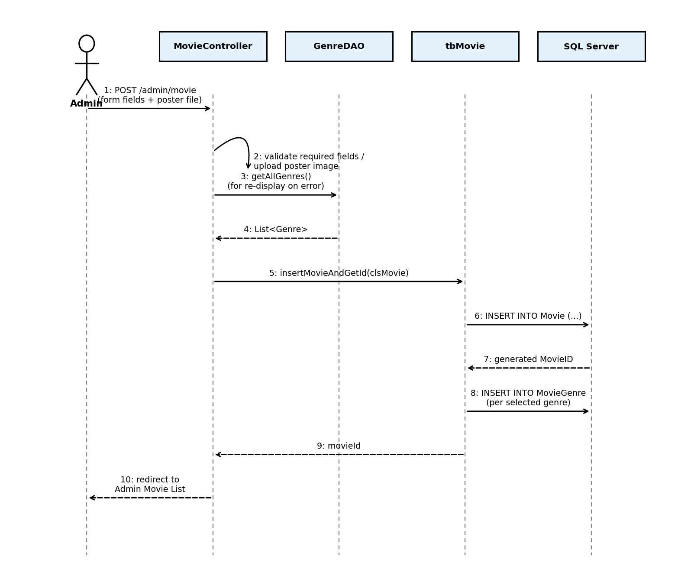
Figure 3.3.2 — Add Movie sequence diagram

3.4 Promotion Management
Covers creating and maintaining discount codes. PromotionServlet is a single servlet that fans out to private handleCreate/handleUpdate/handleDeactivate/handleReactivate methods based on the 'action' request parameter, using nested PromotionRequestDTO / PromotionResponseDTO classes to shape request and response data; PromotionDAO performs the persistence. PromotionStatusScheduler (see 2.2) keeps Promotion.Status current in the background.

3.4.1 Class Diagram
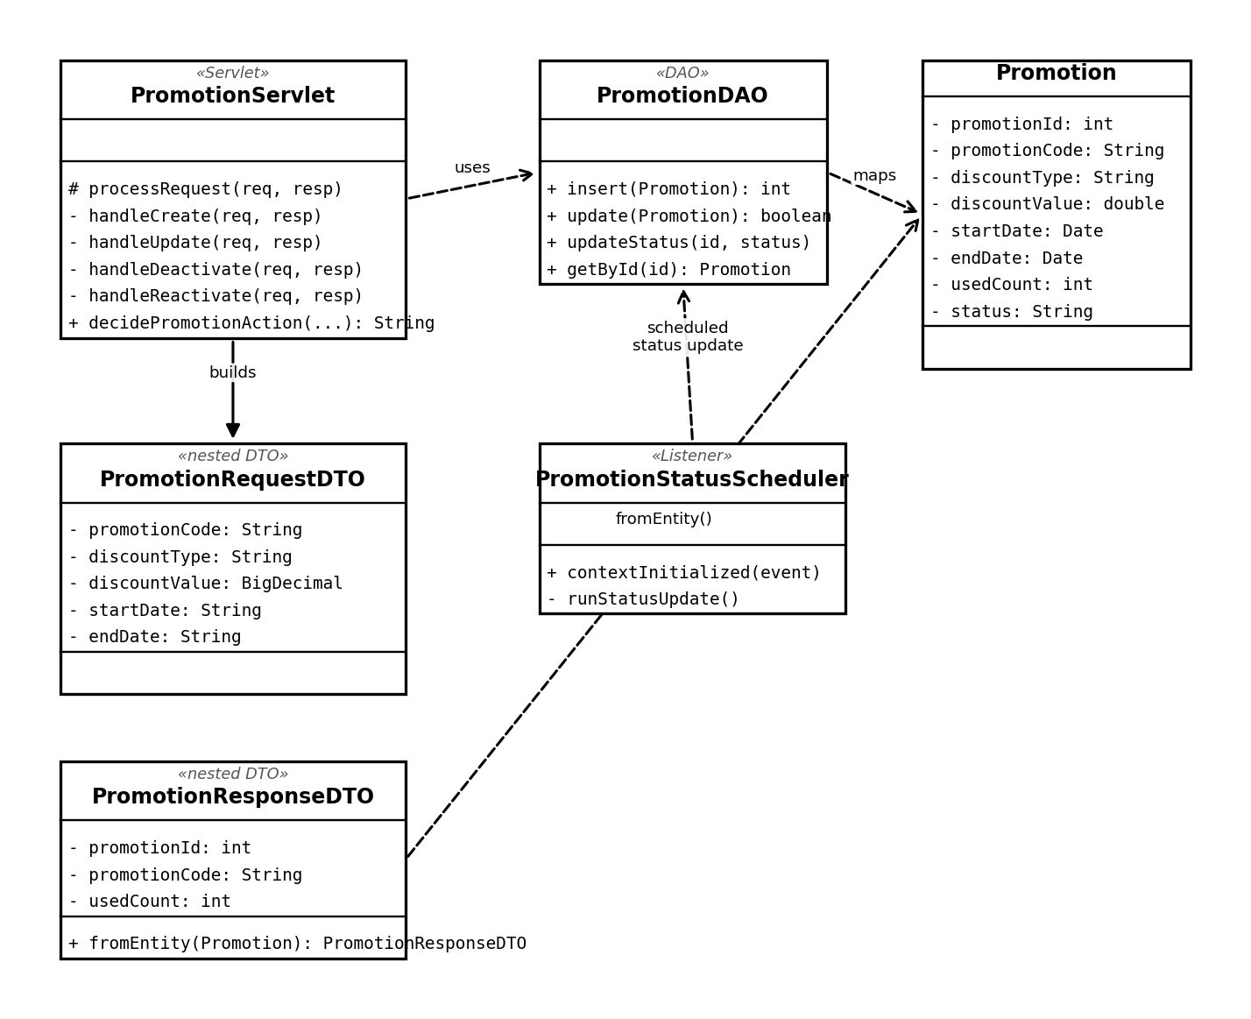
Figure 3.4.1 — Promotion Management class diagram

3.4.2 Create Promotion Sequence Diagram
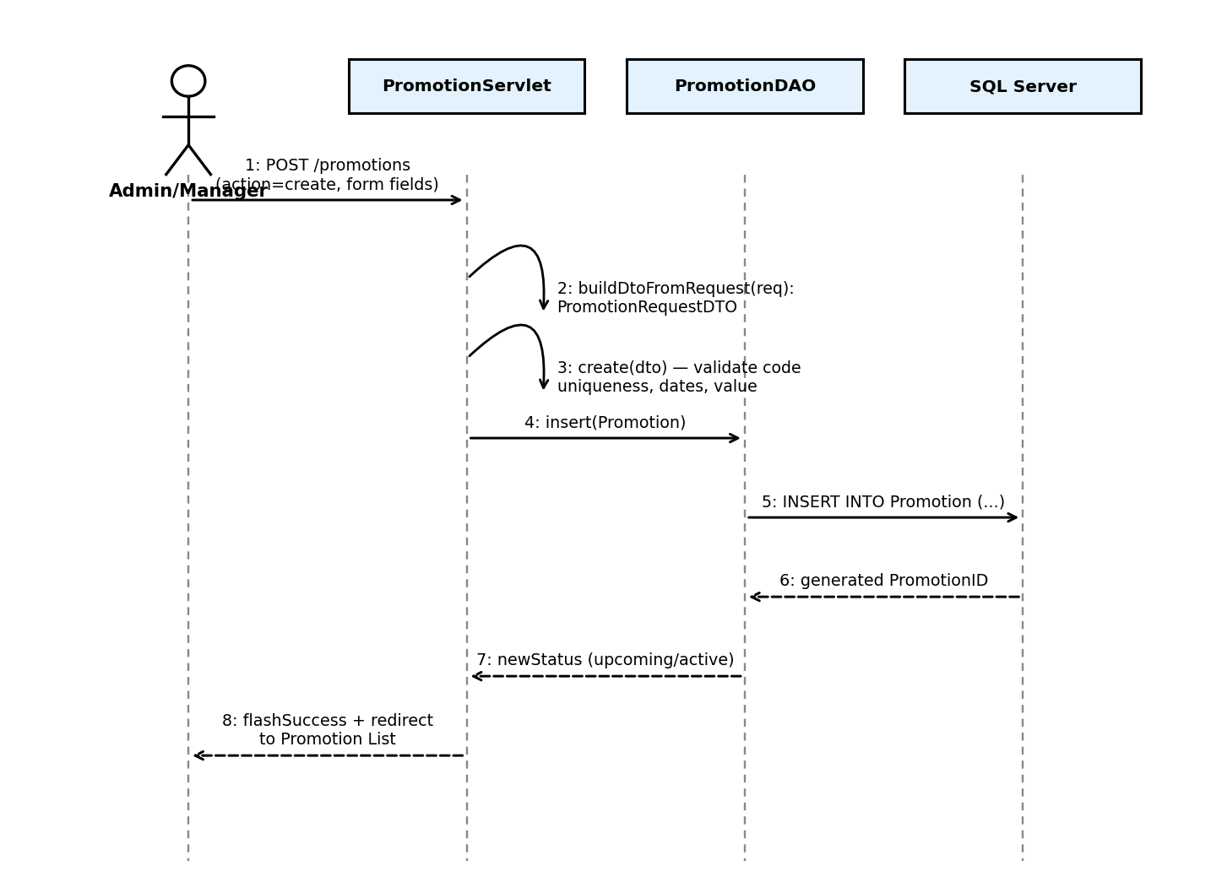
Figure 3.4.2 — Create Promotion sequence diagram

